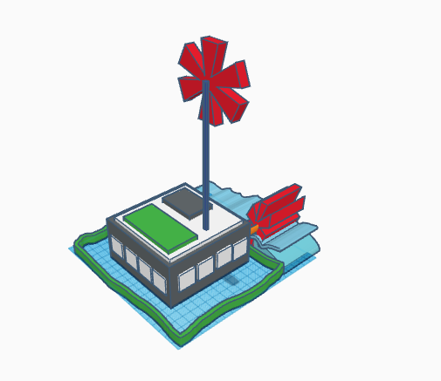

The house is made of concrete with a layer of insulators inside. It uses smart OLED lights in the interior and has a green roof, solar panel, water power generator, and wind turbine.

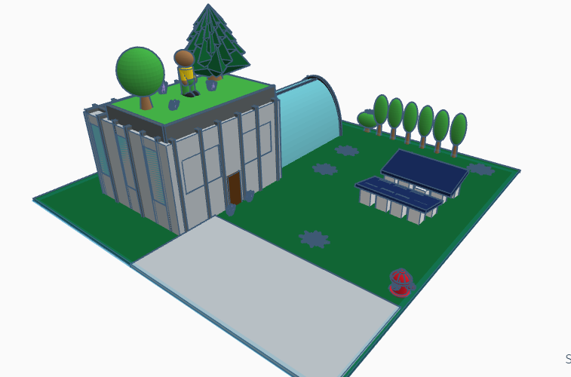

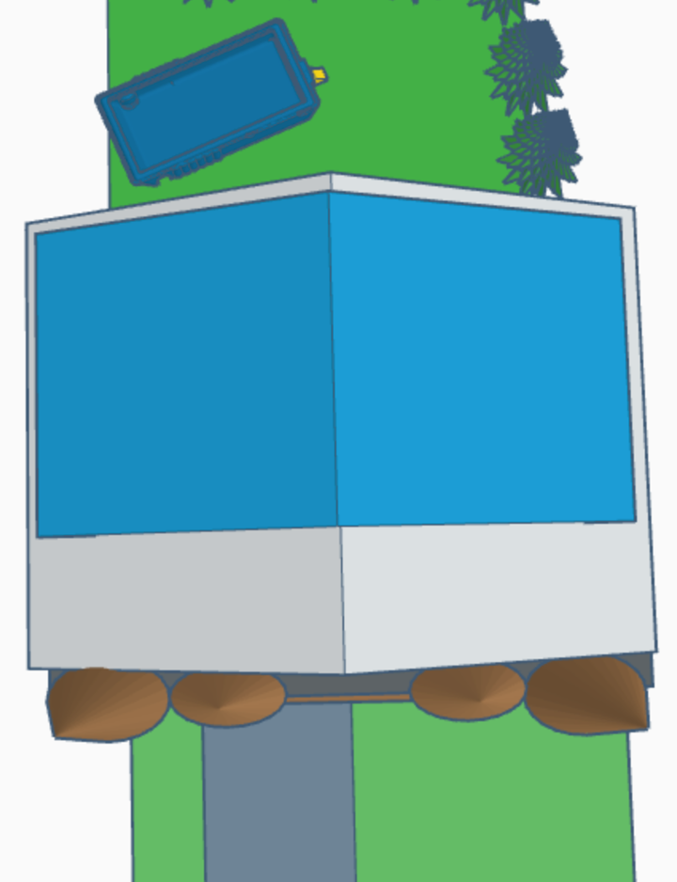 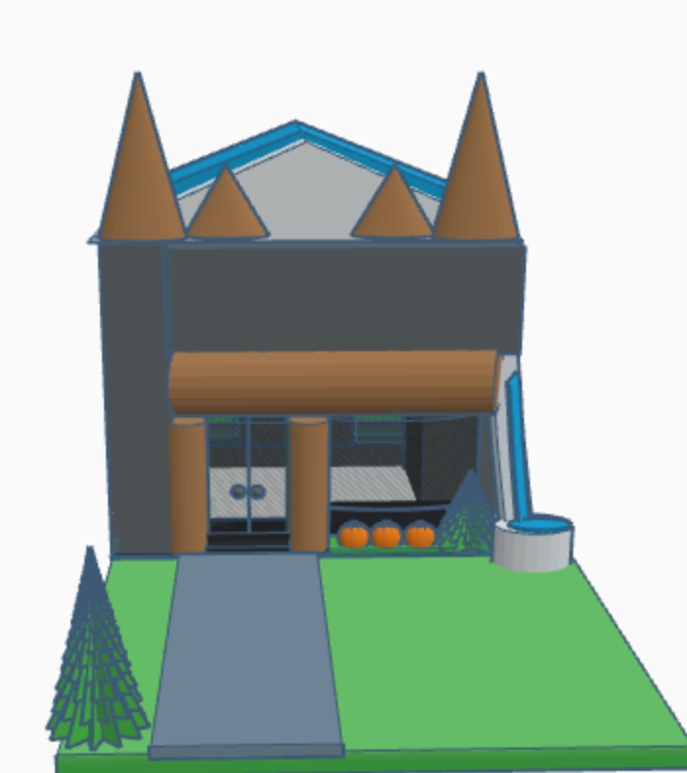 Exterior: Large windows - there are many large windows in the home to bring in the light. The windows are made of a timber frame. The glass has a low - e rating which means that the air from inside does not escape out.
Rainwater collector - there is an area at the front of the house to collect rainwater. It is used for gardening.

Outdoor plants - create fresh air, reduce moisture in the air, add privacy

Veggie and fruit garden - there is a garden so that fresh foods are grown and eaten. They taste fresh and without chemicals. This way you eat healthier and do not have to go to the store as often so you use less gas to drive the car.

Solar panels - they are on the roof facing the south side so that they get the most sunlight. It generates electricity for the house.

Metal roof - this roof is a very strong and durable material. It lasts a long time. It reflects the sun's rays so that it helps with the costs to cool the house.

Wood and Brick outside walls - The materials last a long time. They are durable and keep the structure lasting for a long time.

Interior:
Led lights - these lights are much more efficient than the regular incandescent lights. They use 75% less energy.

Recycled cotton insulation - it's made of reused and recycled materials. It is safe and easy to install. It is also better for your health.

Bamboo wood flooring - bamboo grows much faster than hardwood trees, it is more sustainable and environmentally friendly.
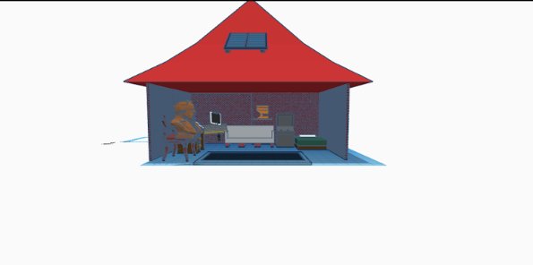

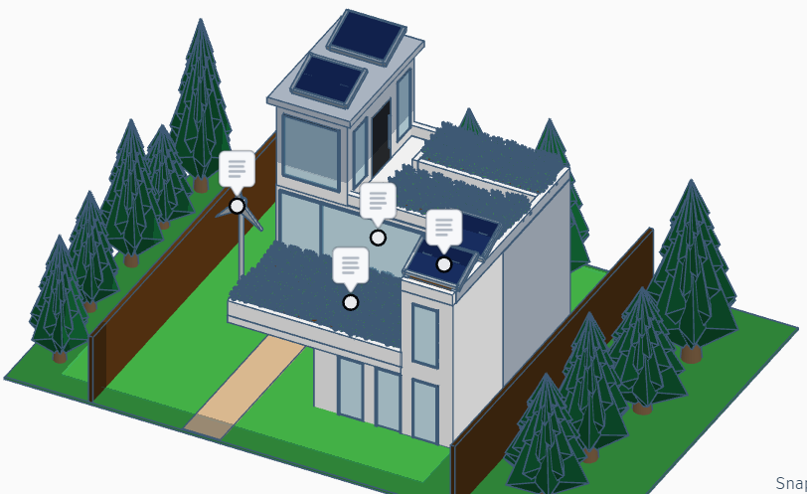

Modern, but energy efficient, this home is a rare sighting. Outside, you will notice the stunning landscape that surrounds the home, the sleek architecture, the vegetation that lies on the green roof, the large elegant windows, and both the solar panels and wind turbine. Once you enter the home, the list of energy efficient features don’t end there, as it comes with heated floors, spray foam insulation, air sealed windows and doors, LED lighting, and the best energy saving appliances.

Natural landscaping is important to have, because it contributes to our well-being and quality of life, creates a happy environment around the home, and purifies the air around us.

Like natural landscape, green roofs are important, as they can provide clean air, the ability to produce food, less energy use, less stormwater runoff, and you’ll also be supporting urban wildlife.
They may not seem important, but large windows can help out a lot, as they are great for natural lighting, and can help heat the home.
Solar panels are a great form of electricity, because of how they can turn sunlight into electric current. Solar panels are also pollution-free, and won’t emit greenhouse gases.
Wind turbines are very similar to solar panels, but instead of sunlight, it turns wind into electricity. Wind power is also one of the cleanest forms of energy. Having both solar panels and wind turbines can provide a consistent supply of energy.
Spray foam is the most energy efficient insulation, sealing cracks and gaps, prevents temperature fluctuations, and makes the home comfortable.
Heated floors can make not only the floors warm, but make the entire room warm. They are quiet, and energy efficient, because the heat from the floor can’t escape.
Having air sealed windows and doors means that wind can’t get in the home. When wind gets into the home, it makes it difficult for heating and cooling systems to regulate the temperature.
LED lights are much better and more energy efficient than incandescent lights, because they last longer, they aren’t so hot, and they don’t use as much energy.
Energy saving appliances are a big help for the environment, and your money, as using energy saving appliances can save money on utility bills because they don’t use as much energy, unlike normal appliances.

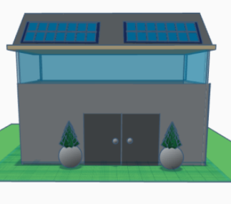

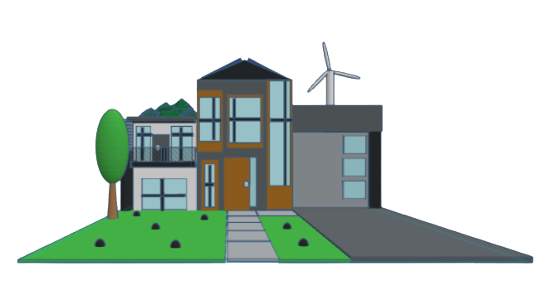

How Wind turbines work: the wind turns the blades, which causes the axis to rotate, the axis is attached to a generator, that produces DC electricity, and is then converted to AC through an inverter that can then be passed on to power your home. The stronger the wind, the more electricity is generated from the motion, and there is an emergency generator in case of outages.

Here are reasons why lots of windows should be made in future homes:
- Large Windows Bring in lots of Natural Light.
- Large Glass Windows Bring You Closer to Nature.
- Large Windows Give You Indoor/Outdoor Living Space.
- Large Windows Provide Solar Heat. so you don't always have to turn on your lights
- Large Glass Windows Give a Spacious Feel.

Green roof benefits: Green roofs have many benefits: it extends the life of the roof, purifies the air , gives shade and creates a cooler home, reduces greenhouse gas emissions, lowers your energy cost, and is a good place to grow your garden on top . When it rains the excess rainwater is gathered in a tank and transferred to the water sprinkler for the front lawn when it is not raining.
How solar panels work: When the sun shines onto a solar panel energy from the sunlight is absorbed by PV cells in the panel. This energy creates electrical charges in response to the electrical field in the PV cells Causing electricity to flow.
How a Geothermal heat pump works: Beneath the earth's surface the temperature is very hot the geothermal heat pump takes advantage of that heat by transferring and concentrating it to provide heat for your home when its cold when it's hot the heat is redirected somewhere else to cool your home
On the outside of the home the windows are sealed with window stripping because moving air is a serious cause of energy loss in a home. Starting off on the inside. The home's insulation is made of spray foam, spray foam is one of the best insulators. Spray foam lasts for approximately 80 - 100 years and against the typical fiberglass spray foam is better because fiberglass cracks under moisture but spray foam does not. spray foam is an insulator that does not get moldy like other insulators, spray foam has the highest R-value of all the insulators, R- value is the measurement of how well an insulator does its job. Spray foam is also flood resistant. Secondly the inside of the home is installed with a smart thermostat. A smart thermostat Is a Wi-Fi enabled device that automatically adjusts heating and cooling temperature settings in your home. Smart thermostats help you save energy, and around 180$ each year. They can be completely customized to the users needs and can be controlled remotely. It learns the habits of the user(s) and generates an algorithmic temperature schedule. The third piece of energy efficient technology in my home is similar to a smart thermostat. It is called a water heater thermostat, have you ever noticed in your house or even at hotels when you turn on the shower water, the cold side is freezing and the hot side feels like your skin is burning, well then those buildings do not have a water heater thermostat. A water heater thermostat regulates the temperature so that the cold side is not too cold and the hot side does not burn you.
The fourth component to my energy efficient home are LED lights. LED light bulbs last longer, are more durable, and offer the same or better quality than other types of lighting LED bulbs use more than 75% less energy than other lighting. At low power levels, the difference is even larger. And unlike standard light bulbs that get very hot when on for a long time Led lights are much more safe. The fifth addition to my home is a cold room. A cold room is a type of refrigeration chamber that is designed to maintain a specific cold temperature; it often has a vent to let in cool air. It is an energy efficient way to preserve food rather than a running refrigerator.

